**HARDWARE & SOFTWARE REQUIREMENTS**

The purpose of the Software Requirement Specification Document is to specify the user goals and tasks that need to be achieve. Software Requirement Specification forms the basis of software development. Software Requirement Specification acts as a reference for validation of the final product. It helps to check if the software has met the requirements. This chapter gives an overview on the following information:

• Hardware Requirements.

• Software requirements.

**Software Requirements:**

 Operating System : Windows

 Technology : PHP

 Server : XAMPP

 Database : MySql

 Cloud : AWS

**Hardware Requirements:**

PC or laptop with following requirements:

• Processor: Intel(R) Core(TM)i3-4005U CPU @ 1.70GHz

• Installed Memory(RAM): 4GB

System Type: 32-bit Operating System

**PROGRAMMING LANGUAGE SELECTION**

PHP is a scripting language primarily used to make interactive web pages. It is a server side language which means it does its processing on a server, a bit like this: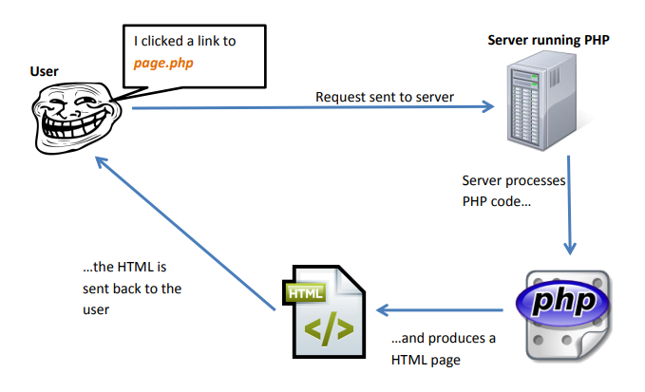

PHP started out as a small open source project that evolved as more and more people found out how useful it was. RasmusLerdorf unleashed the first version of PHP way back in 1994.

• PHP is a recursive acronym for "PHP: Hypertext Preprocessor".

• PHP is a server side scripting language that is embedded in HTML. It is used to manage dynamic content, databases, session tracking, even build entire e-commerce sites.

• It is integrated with a number of popular databases, including MySQL, PostgreSQL, Oracle, Sybase, Informix, and Microsoft SQL Server.

• PHP is pleasingly zippy in its execution, especially when compiled as an Apache module on the Unix side. The MySQL server, once started, executes even very complex queries with huge result sets in record-setting time.

• PHP supports a large number of major protocols such as POP3, IMAP, and LDAP. PHP4 added support for Java and distributed object architectures (COM and CORBA), making n-tier development a possibility for the first time.

• PHP is forgiving: PHP language tries to be as forgiving as possible.

• PHP Syntax is C-Like.

Common Uses of PHP

PHP performs system functions, i.e. from files on a system it can create, open, read, write, and close them. The other uses of PHP are:

• PHP can handle forms, i.e. gather data from files, save data to a file, thru email you can send data, return data to the user.

• You add, delete, modify elements within your database thru PHP.

• Access cookies variables and set cookies.

• Using PHP, you can restrict users to access some pages of your website.

• It can encrypt data.

Characteristics of PHP

Five important characteristics make PHP's practical nature possible:

• Simplicity

• Efficiency

• Security

• Flexibility

• Familiarity

**OVERVIEW OF TOOLS AND TECHNOLOGIES USED**

**XAMPP**

XAMPP,XAMPP stands for Cross Platform(X), Apache(A), MySQL(M), PHP(P) and Perl(P){Practical Extraction and ReportLanguage}.It is a simple, lightweight Apache distribution that makes it extremely easy for developers to create a local web server for testing purposes.Everything you need to setup a webserver–server application(Apache), database(MySQL), and scriptinglanguage(PHP)–is included in a simple extractable file.XAMPP is also cross-platform,which means it works equally well on Linux, Mac and Windows. Since most actual webserver deployments use the same components as XAMPP,it makestransitioningfromalocaltestservertoaliveserverisextremelyeasyaswellXAMPPhasfourprimarycomponents.Theseare:

• Apache:Apacheistheactualwebserverapplicationthatprocessesanddeliverswebcontenttoacomputer.Apacheisthemostpopularwebserveronline,powering anearly54%ofallwebsites.

• MySQL:Everywebapplication,howsoeversimpleorcomplicated,requiresadatabaseforstoringcollecteddata.MySQL,whichisopensource,istheworld’smostpopulardatabasemanagementsystem.

• PHP:PHPstandsforHypertextPreprocessor.Itisaserver-sidescriptinglanguagethatpowerssomeofthemostpopularwebsitesintheworld,includingWordPressandFacebook.

• Perl:Perlisahigh:level,dynamicprogramminglanguageusedextensivelyinnetworkprogramming,systemadmin,etc.Althoughlesspopularforwebdevelopmentpurposes,Perlhasalotofnicheapplications



3.4.2 MYSQL

Structured Query Language is a special-purpose programming languagedesigned for managing data held in a relational database management system (RDBMS).Originally based upon relational algebra and tuple relational calculus, SQL consists of a data definition language and a data manipulation language. The scope of SQL includes data insert, query, update and delete, schemacreation and modification, and data access control. Although SQL is often described as, and to a great extent is, a declarative language (4GL), it also includes procedural elements.

SQL was one of the first commercial languages for Edgar F. Codd's relational model, as described in his influential 1970 paper, "A Relational Model of Data for Large Shared Data Banks." Despite not entirely adhering to the relational model as described by Codd, it became the most widely used database language.

SQL became a standard of the American National Standards Institute(ANSI) in 1986, and of the International Organization for Standardization(ISO) in 1987. Since then, the standard has been enhanced several times with added features. Despite these standards, code is not completely portable among different database systems, which can lead to vendor lock-in.